Contents
Contents 1
Introduction 3
Welcome to Peshk@! 3
System requirements 3
Software installation 3
Technical support service 4
User interface 4
Main menu 5
Navigator 6
Working area 7
Chess board 7
Notation window 9
Task switching panel 10
Status bar 10
Working zone view options 10
System settings 11
Options 11
Player List 13
General modes 14
Solving tasks and move score 14
Changing ELO rating 16
History 17
Statistics 18
Printing 21
Peshk@ wizard 22
How does it look 22
What does it do 23
Activate courses 23
Show Courses List 23
Try Demo courses 25
Update courses 26
Catalog 26
Profile 28
Some new features 30
Download 30
Offline work 30
Speed 30

1. Introduction

Welcome to Peshk@!
Peshk@ is a chess software program that was developed for a number of educational courses that can be used both by beginners and intermediate users for working on the details of the most difficult topics.
Easy-to-use and conceptual program interface allows any user to work and to adjust the software program without any difficulties.
There are tree general modes in Peshk@:
- Learning, when the user solves tasks on the selected topic.
- Test, which is used for scoring and checking user’s knowledge.
- Game against computer, where you can play versus computer.

System requirements
Peshk@ software was developed for Microsoft Windows 2000, XP, Vista and Windows 7 operating systems. If you have any questions about configuration details, feel free to contact technical support service.

Software installation
The installation process launches automatically after you have inserted DVD disk into the drive. Or you can open the folder with PeshkaSetup.exe and run it manually.

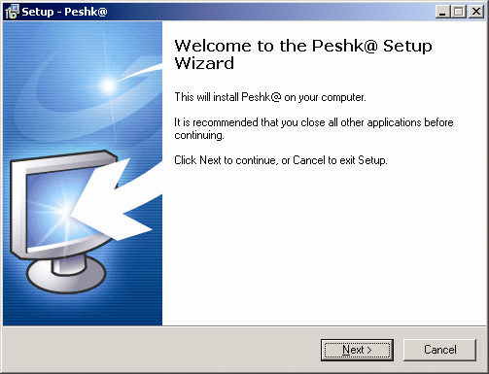
The setup wizard will help you to install successfully Peshk@ on your computer.

Technical support service
If you have any questions or technical problem with Peshk@, please, write us to email info@chessok.com

2. User interface
User interface of Peshk@ consists of three main parts:
- Main menu, which allows you to reach any function or program setting.
- Navigator, which allows you to switch quickly between the lessons.
- Working Area, the area where you actually work with the program.

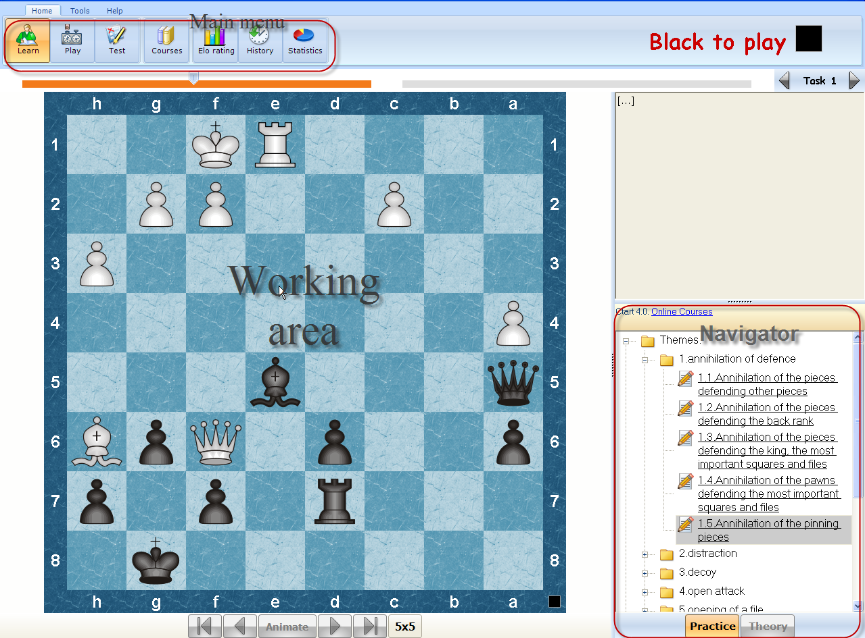

Main menu
Peshk@ Main menu is located in the upper left side of the window. This menu allows you to switch courses or modes, choose students, adjust the program, print etc.
It consists of three elements:
- Tab, includes complete set of operators, which are necessary for working with the program.
- Group, consists of relating operators in the tab.
- Controls, functional buttons on the panel.
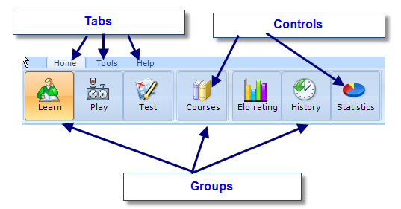
Peshk@ Main menu consists of following tabs: Home, Tools and Help.
Operators in the Home tab are separated into three groups. The first group allows you to choose one general operating mode among three available (Learn, Play or Test), the second group allows you to load and choose required courses and the third group allows you to get access to statistic results and history.
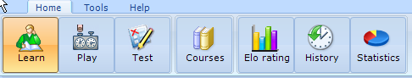
The Tools tab is used for adjusting the view of the program window (First group), changing the user list or setting the program (Second group) and printing (Third group).
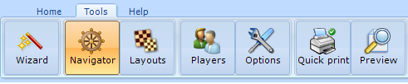
The Help tab provides you with some more reference information.
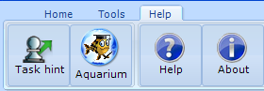
- The Task hint button is used to get hints while solving tasks.
- The Aquarium button exports the current position to Aquarium Sandbox.
- The Help button is used to display additional information.
- The Webupdate button is used for updating the current version of the program to the latest.

Navigator
Navigator functions like a “control panel”, that allows you to switch quickly between the lessons in the chosen course and between modes (theory and practice). To open or close the Navigator window, press the Navigator button, located on the Tools tab.
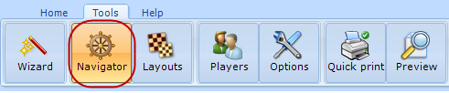
The title of the current course is located in the upper side of the window; the list of available lessons is displayed below. To choose a desired lesson, just find it in the list, scrolling up and down if it is necessary, and click on its title. The program will automatically switch to the first task of the chosen lesson.
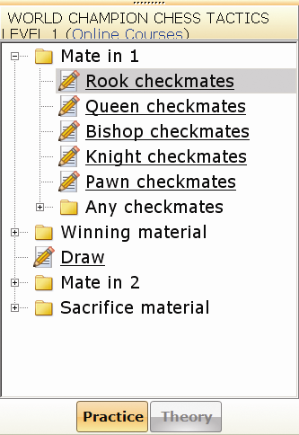
At the bottom of the Navigator window two buttons are located. The Theory and Practice buttons allow you to launch theory or practice mode, if this mode is available in the chosen course. For example, in the Rules of chess and Chess strategy courses both theory and practice modes are available, however in the Encyclopedia of Opening Blunders course only practice mode is allowed. Notice that the Theory button is blocked and displayed in grey.

Working area
Working zone is an area, where you actually work with the program: receive and solve different tasks on the board, switch between available tasks and view other additional information. The working zone consists of four major elements:
- Chess board
- Notation window
- Task switching panel
- Status bar

Chess board
Peshk@ chessboard has a standard view. The coordinates (letters and digits) around the board can be changed to any other; also you can adjust the design of the board and pieces. 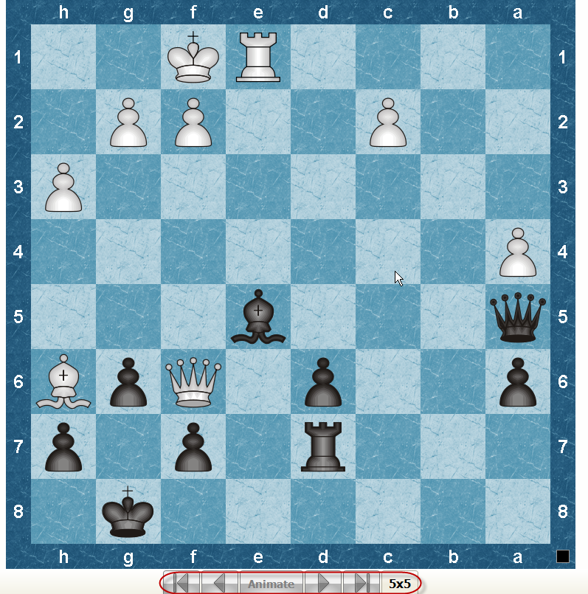
To find out whose turn to move it is right now, take a look at the square indicator in the right part of the board. The indicator changes its color (black or white) and location (up or down) depending on the side that has to move. Also, the color of the player whose turn to move it is now is displayed on the right from the main menu.
Navigation buttons at the bottom of the board allow you to move back or forward through the game. The very left button switches to the beginning of the game. The next two buttons allow you to make one move back or forward correspondingly. The very right button switches to the end of the game. The move sequence can be played by clicking on the Animate button.
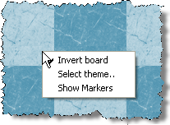
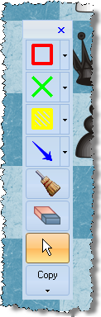
The menu that appears when you make a right click on the board consists of the following functions: invert board, select theme and show markers. If you choose the second option, a dialog window, where you can select new board or pieces design, will be displayed. The last one provides the markers on boards, as in Aquarium
You can pick one of the available designs in the list or create new, for example in case if you have worked it out one by yourself. Just click on the Add button and open the directory where the new design is located. To delete an existing design select it in the list and click on the Remove button.

Notation window
The notation window displays the moves and the comments that have been made during the game. If the Theory mode is enabled in the current course, you will find some theoretical information that is necessary for solving different problems and scoring moves that have been made. You can also find additional information about players and the place where the game was held.
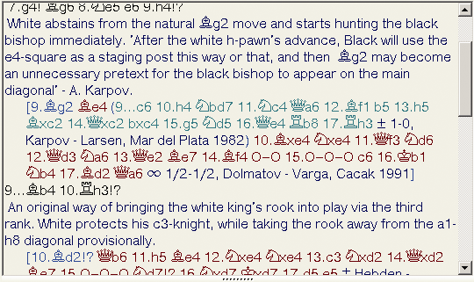
If you click on any move in the notation, the move will become current and the position after this move will appear on the board. The user is able to playback the moves on the board, which are listed in the notation, starting from the current move. If you click on the > button on your keyboard the next move will be made. If you press < - the previous move will be made. If the current move is located in a variant, that variant will be played.
To playback the main task variant automatically (without other variants), press on the Animate button, which is located under the board. To stop the move playback press on the Animate button one more time.

Task switching panel
The task switching panel is located under the main menu of the program.
The biggest part of the line consists of rectangles; their number equals to the number of tasks in the selected lesson. When you switch to the next task, the trigger moves to the next rectangle and the number of the current task appears on the right side. If the problem was solved correctly, it is marked with dark-grey color on the task switching panel. Otherwise it is marked with orange. Unsolved tasks are colored in grey.
There are two ways to switch between the lessons:
- Move the trigger. Click on the trigger and move it to the required task.
- Click on < or > buttons to switch to the next or to the previous task.

Status bar
The status bar, where you can find information about the solving process, is located at the bottom of the window. It includes:
- current mode
- overall number of tasks in the lesson and the number of the current task
- scores in the current task
- the number of wrong moves
- time spent
- additional data (turn to move, result etc)

Working zone view options
You can adjust the view of the Peshk@ working zone according to your own preferences. To open or close the Navigator window click on the Navigator button, located in the Tools tab.
To rearrange the board, notation window and navigator, press on the Layouts button, located in the Tools tab of the main menu. The board, notation window and navigator will be automatically scaled.
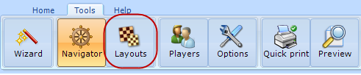
The size of the notation window can also be changed manually. Depending on its placement on the screen click and drag the boarder of the notation window with another window to adjust its size.

3. System settings
In this section you will find instructions about the main Peshk@ settings, which are necessary for working with the program.
- Options
- Users list
- Course Browser

Options
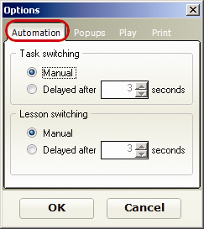
To adjust the settings of the Peshk@ press on the Options button, located in the Tools tab of the main menu.
Automations tab
There are two ways to switch between the tasks or between the lessons of the chosen course: manually (Manual) or automatically (Delayed after). To select the automatic method, set the delay time in seconds (1 to 10)
Popups tab
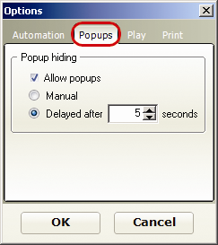
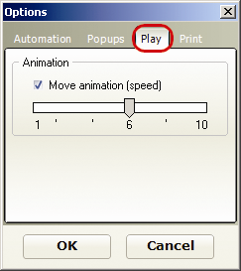
To allow displaying popup informational windows, enable Allow popups select one of two options: Manual (the windows will be closed by clicking) or Delayed after (the windows will be closed after user-defined time).

Play tab
If Moves animation is enabled, then the automatic move performance is turned on. The number of moves that the program will display are set by moving the trigger to desired location. This setting can take on a value from 1 to 10 moves.

Print tab
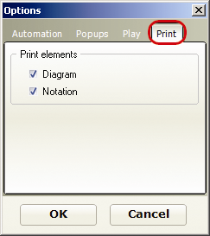
After adjusting the settings click on the OK button.
More about printing in 4.5 Printing.
Engines tab
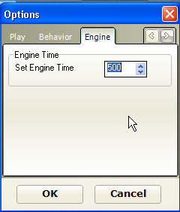
Here you can specify the time, given to an engine for thinking about the move.

Player List

Peshk@ stores statistic database for each registered user. To open the user list click on the Users button, located in the Tools tab of the main menu.

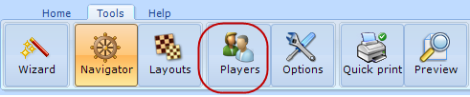
The opened dialog window displays full list of registered users and their current ELO rating. The title of the window shows the name of the current user, also the name of the current user is highlighted in the general list.
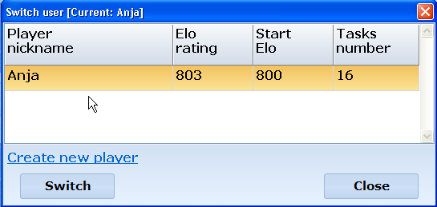
To add a new user, click on the Create new player line. The following dialog window will appear:
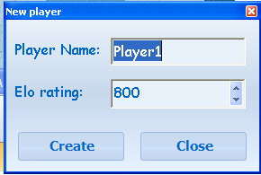
Type your username and initial Elo rating and click on Create button. To switch the user, click on the Switch button.
To access the courses, located on the Peshk@ server you have to be authorized. This is done via Peshka@ wizard, see 5.Peshk@ wizard.

4. General modes
The product provides several working modes, which can differ depending on the chosen course. In the course for beginners both Theory and Practice modes are available; in more difficult courses only the practice mode can be used. It is separated on the three modes:

- Learn
- Game against computer
- Test

Solving tasks and move score
In response to a correct move made by user, Peshk@:
- makes retaliatory move, offering the user to make the next move.
- accepts the move, but also offering other variants for consideration. When additional variant is over, the program returns to the main variant.
If you made incorrect move, the program returns the piece to the previous position, penalizes and gives a hint.
- The first hint includes markers, which disappear after making the correct move. The program marks the most important fields (squares are marked with color) and possible moves (arrows).
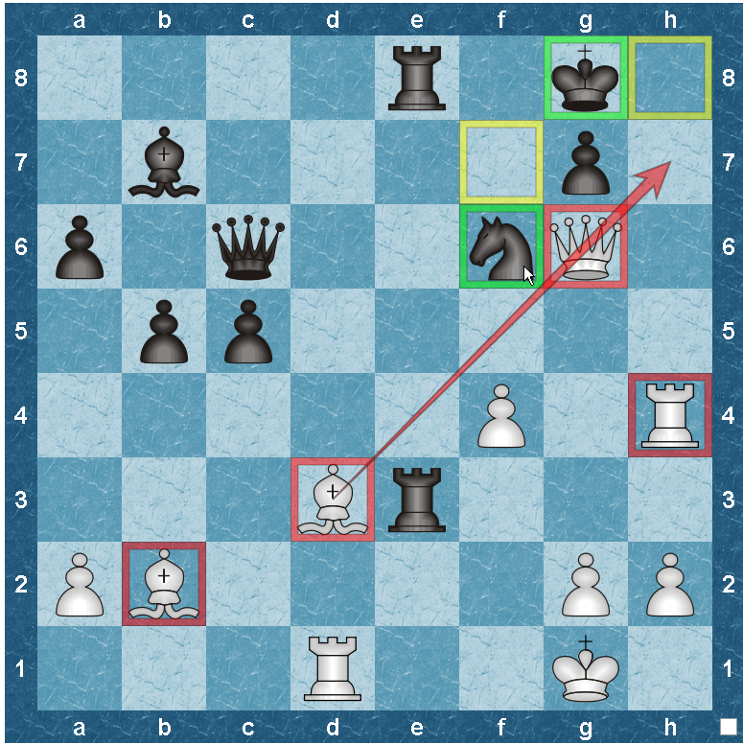

- The second possible hint is blinking of the piece that has to be moved.
- Even if the second hint wasn’t helpful enough and the user made a mistake again, the program will make the correct move by itself.
The number of points for each task depends on its difficulty. For incorrect moves the user is penalized: 20-50 percents from the maximum number of points. The penalty also depends on the difficulty of the task and place of mistake in the solution.
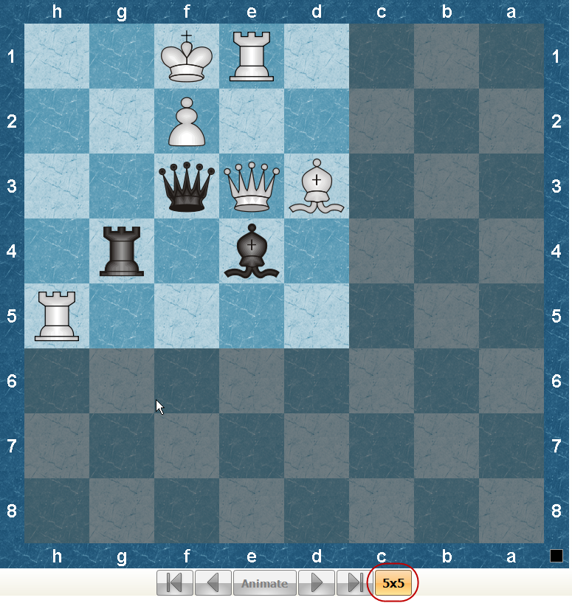
If while solving the task the user made no correct moves, 0 points will be given. On the task switching panel such task is marked with orange.
If user makes a move that is controversial to the chess rules, Peshk@ consider this as carelessness, but not a mistake, so the user will not be penalized. The piece will be returned back to the previous position and the program will wait for another move.
In some courses (such as CT-ART 4.0) “5x5” hint is available. You can get it by clicking the “5x5” button under the board.
This lets you solve a simple similar exercise on “5x5” board to get a hint on how to solve the main one.

Changing ELO rating
Peshk@ calculates user’s rating after finishing the test. Size of Elo rating changing is displayed in the upper side of the settings dialog window. Depending on the results the current rating can be changed as follows:
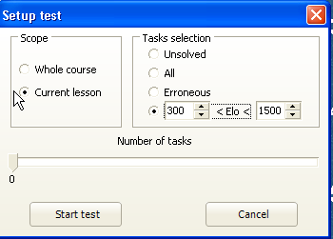
- if none of the tasks was solved correctly the rating decreases to the left limit of the range.
- if all tasks were solved correctly the rating increases up to the right limit of the range.
- if only some tasks were solved correctly, the rating increases or decreases depending on the test score.
The rating range depends on the selected number of tasks in the test. More tasks you have chosen, higher rating you will get having solved the test correctly.
To get statistical information about Elo rating changing click on the Elo Rating button located in the Home tab.
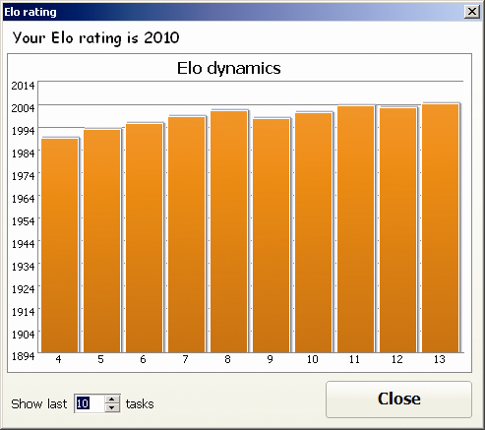
The following window will be opened:
The Elo rating dynamics is shown on the diagram.
The current rating can is displayed in the upper side of the window, above the diagram. In the lower side of the window you can set the desired amount of tests that will be used in the diagram.
The statistics is displayed after the test is complete. Just click on the Elo rating link to watch it.

History
For each user Peshk@ stores information about solved tasks. To see these tasks click on the History button in the main menu.
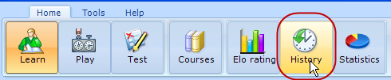
The following window will be opened:
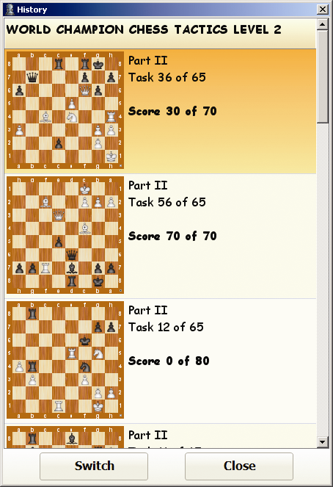
The title of the current course is displayed in the upper side of the window; below you can find the list of tasks that were solved by user.
The first task is on the end of the list and the last task is in the top of the list.
For each task the program displays the title of the lesson, its number, overall quantity of tasks, the number of mistakes, the maximum score for a correct solution, diagram and the score received.
If a task was solved several times, the History window will display only the result of the last try.
To switch to one of the solved tasks, click on the required title and then press on the Switch button.
To look through the history of solved tasks in any other course, click on the Courses button, select the required task and click on the History button one more time.

Statistics

For each user Peshk@ stores statistical information about solved tasks. To watch the statistics, click on the Statistics button, located in the main menu of the program.
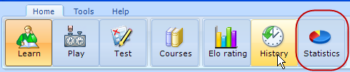

The left side if the window displays the list of all course lessons. To open statistical data, double-click on the title of the desired lesson.
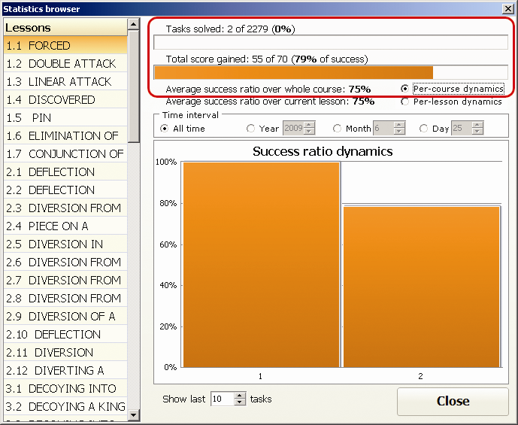
The following information is given for each lesson:
- the number of tasks solved – 2
- total number of tasks in the lesson – 2279
- total percentage of success (Total score gained), which is calculated dividing the total score sum by the maximum score - 79%
For example, you receive 40 points out of 40 for the first task and 15 out of 30 for the second one. Totally, your success ratio is (40+15) / (40+30) = 0.79 = 79%
- Average success ratio over current lesson equals to arithmetical mean of all lessons success ratios.
For the first task the success ratio is 40/40= 100% For the second task the success ratio is 15/30= 50% Average success ratio over current lesson is (100+50) / 2 = 75%
The diagram in the lower side of the statistics window displays the dynamics of that ratio after solving each task. Enable Per-lesson dynamics and set required number of tasks you want to be used in the diagram.
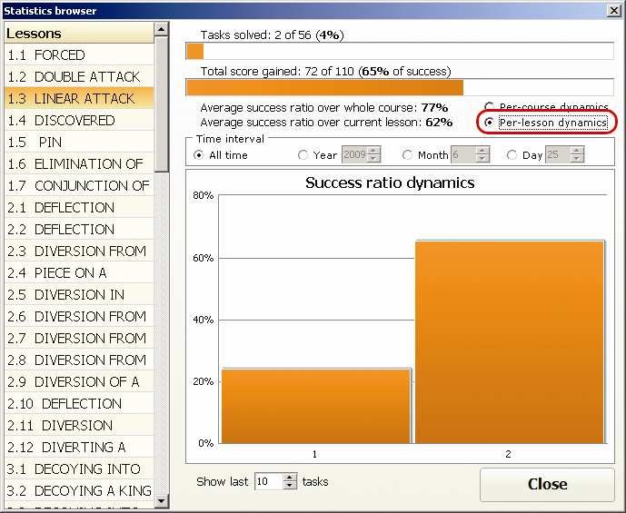
The picture shows the dynamics of the success ratio for three solved tasks.
The following data is displayed for the whole course:
- Average success ratio over there whole course, which equals to arithmetical mean value of all lessons success ratios.
For example, if a user solved two lessons with total success ratios 24% and 100%. Then average success ratio will be = (24+100) / 2 = 62%
The diagram in the lower side of the statistics window displays the dynamics of that ratio after solving each task. Enable Per-lesson dynamics and set required number of tasks you want to be used in the diagram.
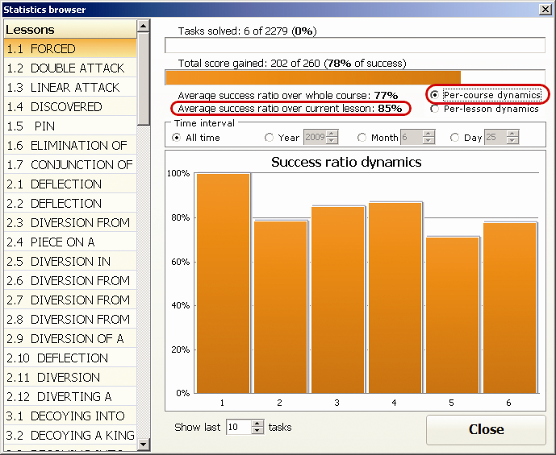
The picture shows the dynamics of the success ratio for three solved tasks.
Time interval sets the time interval for the statistics:
- All time
- Year, month, day. The current day is set by default.

Printing
Switch to the Tools tab of the main menu to access to the printing options of Peshk@.
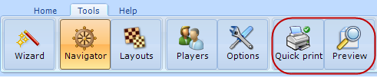
Click on the Options button, select Print and enable the following checkboxes:
- Diagram, if you want to print the games only in form of diagrams.
- Notation, if you want to print only the notation of the game.
- Both checkboxes, if you need to print diagrams and notation.
After adjusting the settings click on the OK button.
Click on the Preview button in the Tools tab of the main menu to open the preview window that shows how the printing positions/games look on the paper.

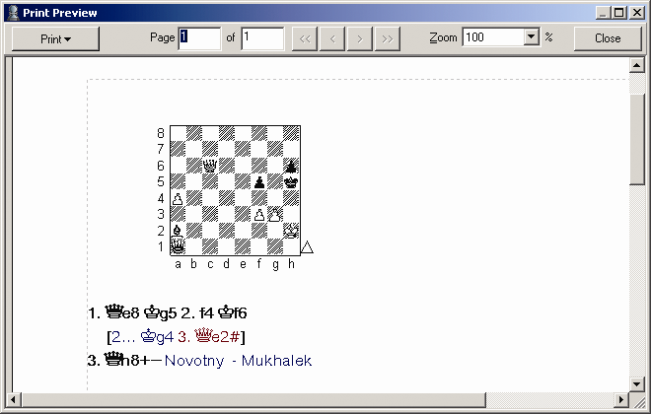
The Zoom setting allows you to set the percentage of the image size of the information for printing. The change of the size relates only to the image, but not to the printing. To print all pages, click on the Print button and select “All” option. To print the current page, select “Current”.
The left window in the ‘Page’ section shows the current number of the page, whereas the right window displays the total amount of pages. You can browse pages using < and > buttons. You can also type the number of the desired page in the left side of the Page block and press [Enter]. The << and >> buttons allow you to switch to the first or last pages correspondingly. To close the Print preview window, click on the Close button or press [Escape] on your keyboard.
In case of need change the printing settings and click on the Quick Print button. The game will be printed.

5. Peshk@ wizard

No, it’s not a setup wizard you’re familiar with! It’s our new Peshk@ Wizard – a compact and useful thing to coordinate your activities with Peshk@.

How does it look
Peshka@ Wizard is a window that use see after opening the program; also it can be reached from Peshk@ itself (Tools-Wizard)
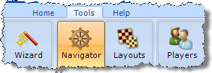
The Wizard itself has the following view:
The blue buttons are the ones you can use now; if the button is gray, it means you are not able to use them. For example, Activate courses
button is gray when you’re offline or unlogged.

What does it do

Activate courses
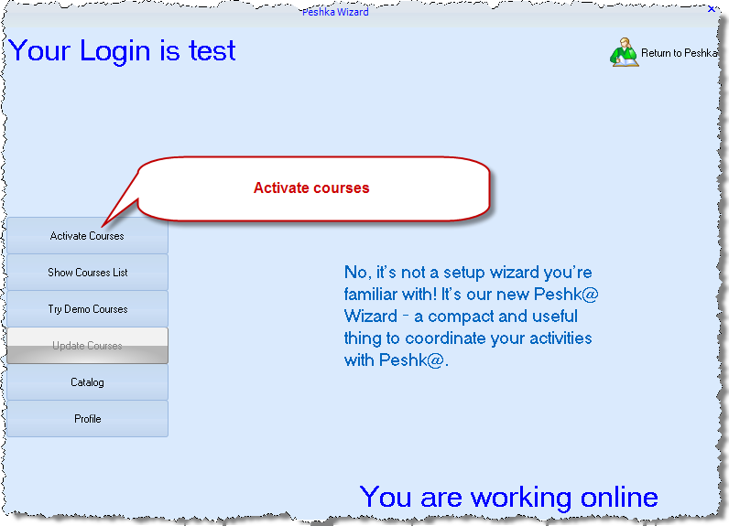
It’s a very small, but important tool used to activate courses. Enter you code (without the prefix crsa://) and the courses will e activated.
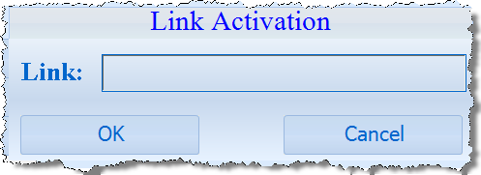
Link activation button is gray if you are offline or not logged in. Your online status is printed in the right bottom corner of the Wizard, your login status – in the left upper corner.

Show Courses List
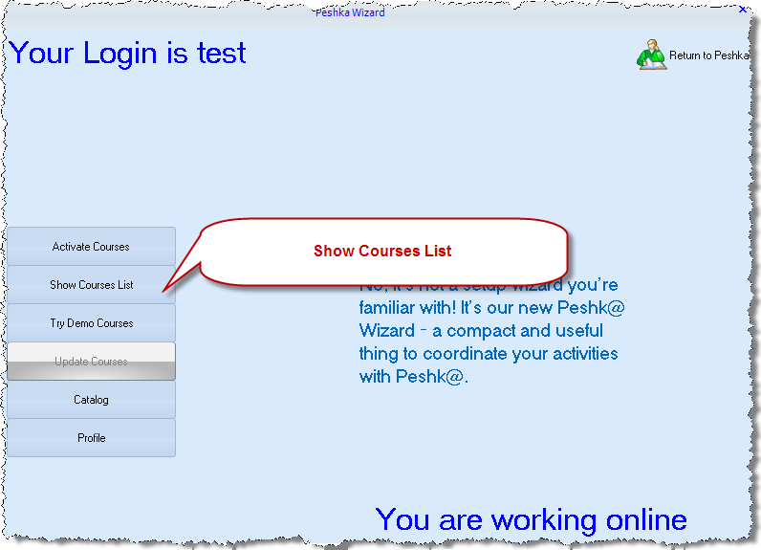
It’s the list of all the courses available now, except DEMO ones. That means it’s a list of all the courses you have bought, both downloaded and not yet.
The download symbol 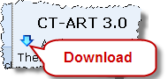 left to the name of the course shows that it’s not downloaded yet. You are able to download courses only if you are online and logged in. Your login status is shown in the left upper corner; your online status is on the right in the bottom.
Double-click on the course opens it in Peshk@. If the course is not downloaded yet, it’ll be done automatically.
In the top of the window you can see the filters that help you to search through the courses. You can choose the difficulty and the theme of the courses to display or just find a course by name.
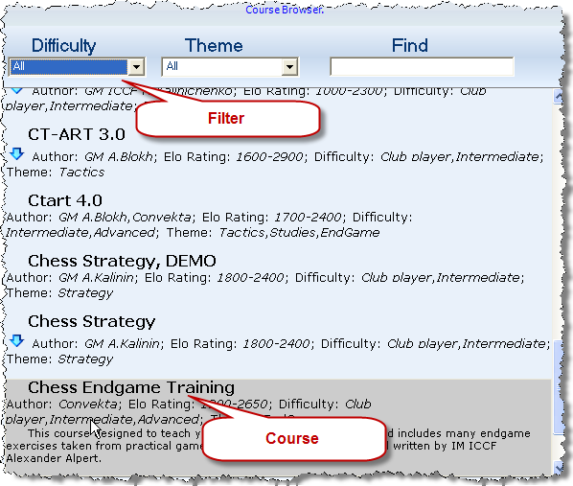

Try Demo courses
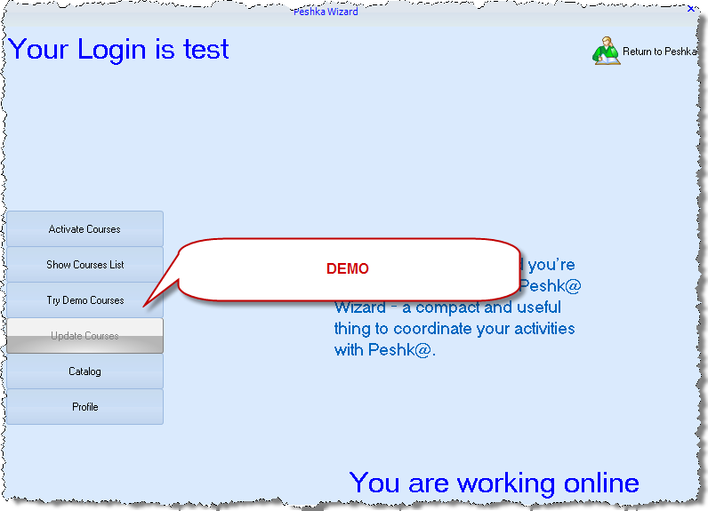
It has just the same look with the Show Courses List window. The only difference is that there you see only demo courses. Double click on the course will open it in Peshk@. If the course is not downloaded yet, you see a download symbol to the left of the course. You are able to download courses only if you are online and logged in. Your login status is shown in the left upper corner; your online status is on the right in the bottom.
In the top of the window there’re the filters that help to sort the list and find the courses. See “View Courses List” for more details.

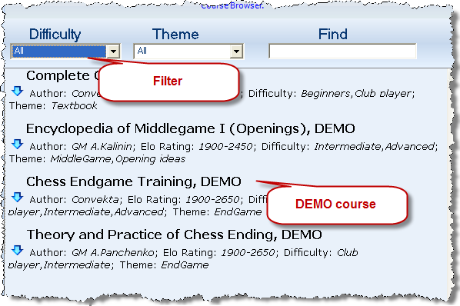

Update courses
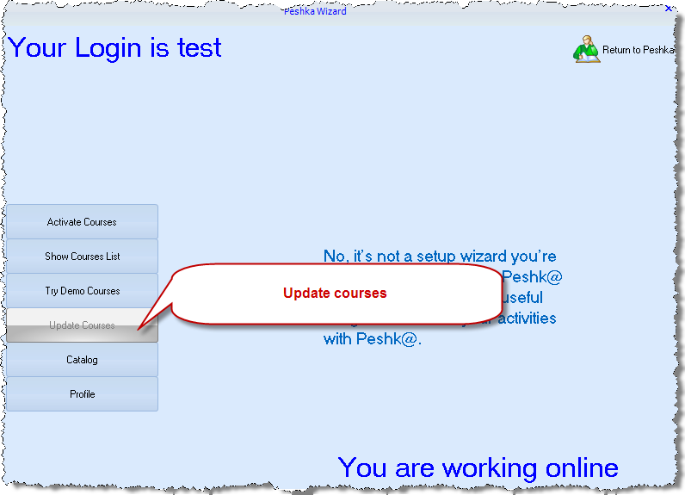
This button is nearly always gray, which means that it’s not needed. But if there’s a new version of the course you already have, it will become blue and on the click the courses will be updated.

Catalog
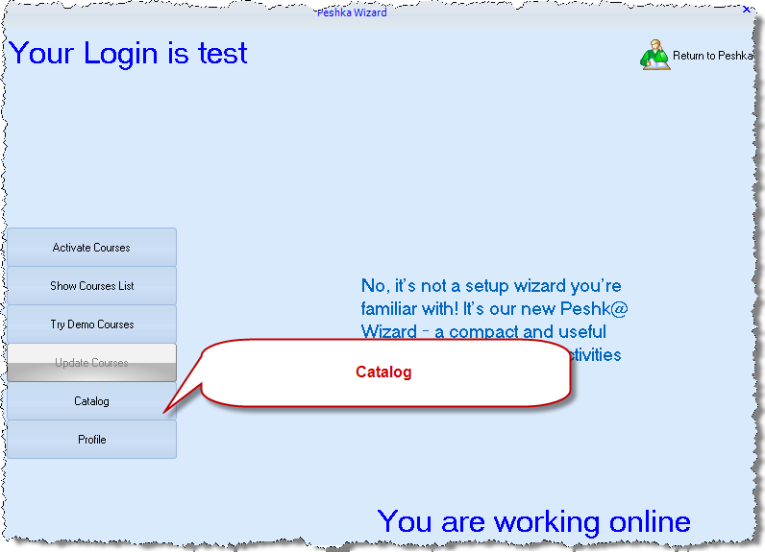
Once again the same window!
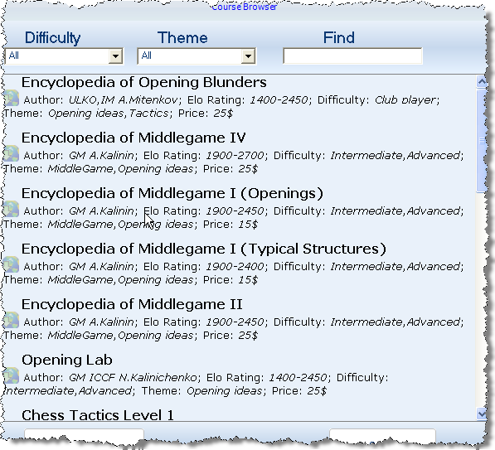
But in fact it’s the list of courses you can buy. As usual, you can sort them by theme and difficulty (See “Show courses list”). And, as usually, you are able to download courses only if you are online and logged in. Your login status is shown in the left upper corner; your online status is on the right in the bottom. If you are unlogged or not registered, the button is gray.
After you double-click on the course, you will see the question window:
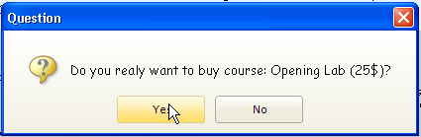
And after you click “Yes”, the course will be bought, downloaded and loaded automatically, and vanishes from the catalog. You can continue exploring Catalog, or go to Course List to choose your courses.
If you don’t have enough money, you will see this dialogue:
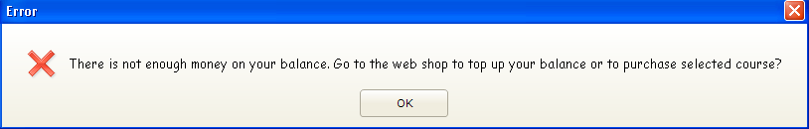

Profile
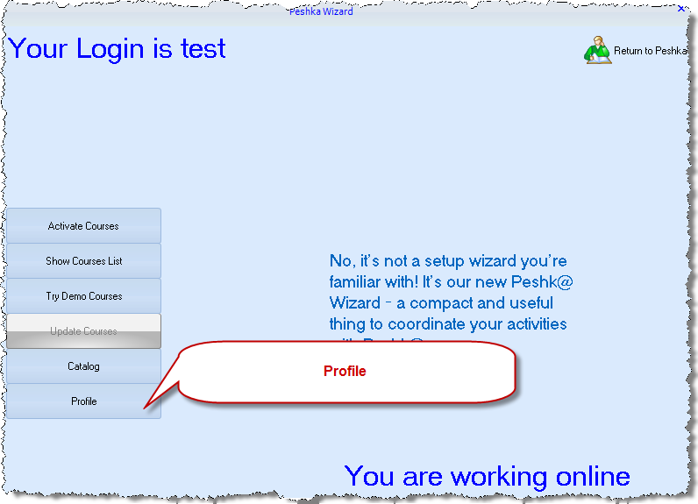
Profile is your account manager. Note, that account is your login at Chessok.com, which is used to buy and download courses. It’s not the Peshk@ user, that is just a gamer.

Login
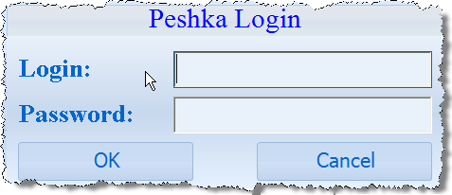
Enter your login in Chessok.com and password to log in. It’s needed to go online and download courses. If you’re not registered, or registered and offline, you can only work with courses already downloaded.

Forgot Password
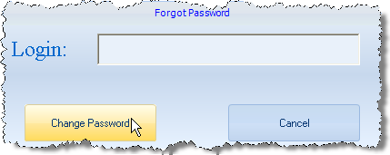
This is needed to restore the password, if you’ve forgotten it. Note, that to restore the password, you need internet connection.
If you’ve entered false login (that doesn’t exist), you’ll see the following dialogue:
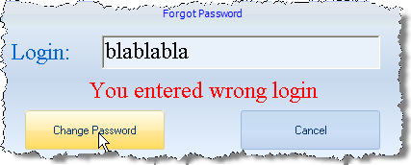

Register new account
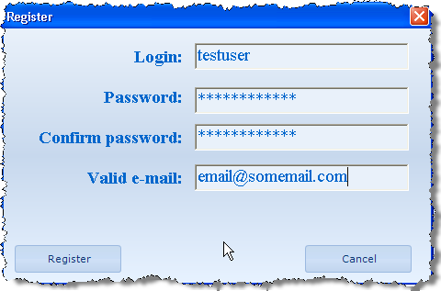
It’s not a new player; it’s a new account in Chessok.com! Basically you need it only once – before you’ve downloaded your first course. After that you only need to login, when you run Peshk@.

6. Some new features

Download
Now nearly all download is performed automatically. After you buy course from Catalog, it’s downloaded. And if you enter your Activation Link (after buying from ChessOk.com), you’ll see Courses List, from which you can both open courses and download them.

Offline work
You have no internet connection, but still want to work with Peshk@? Offline work is also possible, but, of course, you can’t buy new courses. Click on Return to Peshk@ button


Speed
The new Wizard works much quicker than the old course browser. The only place where you might have to wait, is course downloading, because this depends on your network speed. But as long as it goes in background, you can play in Peshk@ while downloading courses.

Dear customer,
This program was produced by CONVEKTA Ltd.
Please contact us:
Support: info@chessok.com
Sales: sales@convekta.com

http://www.СhessOK.com
New Training Courses
How to Win Miniatures at Chess
This course is intended for club players and includes more than 5900 exercises for mating in 2 moves in the opening and about 700 ones for mating in 3 or 4 moves. All the exercises are taken from practical games and arranged according to the names of openings.
Attack on the King I
If you a beginner but already know how to mate in 1 move, you have to move on and learn how to attack a king and give mate in 2 moves! This course includes 33 000 exercises from masters’ games. In every exercise you will have to find a best continuation for an attack against the king.
Attack on the King II
This course includes more than 2500 exercises for mating in 3 or 4 moves. You will have to use your fantasy and precise calculation in order to find a correct way of attacking the king.
Elementary Chess Combinations
This course includes more than 5000 exercises for beginners on the following tactical methods: “Fork”, “pin”, “double check”, “discovered check”, “annihilation of the opponent’s king defense”, “exploiting a back (1st) rank weakness”.
Chess Combinations for Club players
Chess Combinations for Club players is an indispensable training tool for club players. This course includes more than 2000 exercises on the following topics: “annihilation of defense”, “decoy”, “interception” and “distraction”.
Chess: Easy Ways of Taking Pawns and Pieces
This course includes more than 5800 exercises with lots of pieces on the board. Such a great number of exercises makes this course an excellent tool for quick training of chess beginners. Even if you study and solve only 20% of exercises you are sure to improve your chess skills and not to miss a chance to take an undefended piece in your practical game!
Chess: Simple Defense
If you are a beginner, you just have to learn how to defend your pieces from being taken! Every chessplayer has to master and consolidate some basic defensive skills such as withdrawing or protecting a piece, interception or attacking an opponent’s piece. Having consolidated your knowledge by doing a great number of exercises you will be able to improve your level of playing. This course includes more than 3000 exercises with lots of pieces on the board. Such a great number of exercises makes this course an excellent tool for quick training of chess beginners.
Chess Tactics ART 4.0
Finally a new and improved version of the legendary CT-ART has been released! This excellent tactics course has been voted more than once by the chess experts as the best chess training program. CT-ART is an indispensable training tool for intermediate players. The new version sports a convenient user interface and adds 1,000 training exercises (2,200 basic exercises and 1,800 auxiliary exercises altogether).

http://www.СhessOK.com
Rybka 4 Aquarium
Rybka 4 Aquarium offers advanced analysis functions, game commenting, searching, powerful chess trees, playing, databases and much more.
Interactive Deep Analysis is the most advanced chess analysis method available today and is greatly enhanced in Rybka 4 Aquarium. It's completely new approach makes it an essential weapon in the arsenal of every serious player and analyst!
- Simultaneous analysis by multiple Rybka instances. Use 2, 4, 10, 20 or even 50 chess engines at the same time for faster results! Use the computers on your home network or connect to computers over the internet to increase the analysis power!
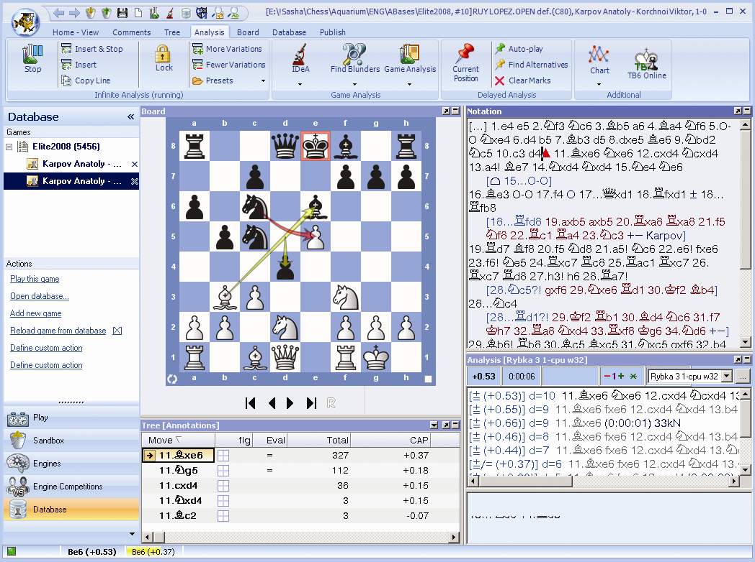

With a Rybka 4 Aquairum DVD you will also get a bonus of Openings Encylopedia 2010 DVD, which includes rich theoretical material on all the openings.

http://www.ChessOK.com

